Rigor Hands-on Exercises for RDBMS

Normalization and Entity Relationship Diagram
- Normalize the table with following columns and draw Entity Relationship Diagram. (Emp_no,Name,Job,Sal,Grade,Proj_id,Proj_name,Proj_desc,PM,Proj_start_date, Proj_end_date).
- Normalize the table with following columns and draw Entity Relationship Diagram. (Po_no,Po_date,Cust_no,Cust_name,Item_no,Item_name,Qty,UOM)

SQL Queries
Create a table by running the following statement and insert the data.
CREATE TABLE Student (
sno NUMBER PRIMARY KEY
,standard VARCHAR2(10)
,section VARCHAR2(10)
,sname VARCHAR2(200)
,sci NUMBER(10,2)
,mat NUMBER(10,2)
,phy NUMBER(10,2)
,lang NUMBER(10,2)
)
- Display the details of all the students whose total marks is greater than 300.
- Display the details of all the students who got have got average marks greater than 60.
- Display the details of all the students who are failed in Science and Mathematics.
- Display the details of all the students who failed in all subjects except Mathematics.
- Display the details of all the students who passed in all subjects.
- Display the details of all the students who are failed in all subjects but total marks is greater than 120.
- Display the details of all the students who are passed in all subjects and name starting with 'S' and ending with 'A'.
- Display the last name and job id of employees earning more than $15,000.(Note. Use Employees table).
- Display the employee last name and manager id for employee with employee id 101.
- Display the Last name, salary, commission for all employees whose salary is in the range of $10,000 and $20,000.
- Display the employee last name, hire date and department id of employees hired between 25th December, 1989, and 17th March 1992. Sort the row with respect to hire date.
- Display the structure of employees table.
- Display the output similar to screenshot given below.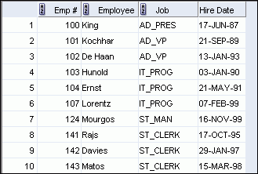
- Display the last name concatenated with the job ID (separated by a comma and space) and name the column Employee and Title.
- Display the last name, job id and manager Id of all employees who are reporting to 100 or 101 or 102. Sort the records in alphabetical order by last name.
- Display the first name and salary of employees who earn not between $12,000 and $21,000, and are in department 10 or 40. Label the columns Employee and Compensation, respectively.
- Display the first name, salary and department id of all the employees who were hired in 1990.
- Display the last name, salary and department id for all the employees who don't earn commissions. Sort data in ascending order of salary.
- Display the last names and salary of all employees where the third letter of the name is an 'e'.
- Display the last name, salary and department id for all employees whose job is Sales representative or stock clerk and whose salary is equal to $15,00, $17,000, or $10,000.
- Display distinct job ids.
- Display the output as given below.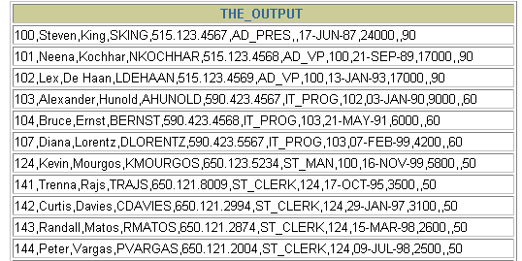
- Display last name and salary of employees who earn between $5,000 and $12,000, and are in department 20 or 50. Label the columns Employee and Monthly Salary, respectively.
- Display the last name and job title of all employees who do not have a manager..
- Display the last name, salary, and commission for all employees who earn commissions.
- Display the last name, salary, and commission for all employees whose commission amount is 20%.
- Display the last names of all employees who have both an “a” and an “e” in their last name.

